Exercise 1 (Packages) Your creativity

1. Create three packages, think of them yourself
2. Put two different classes in each package
3. Import all three of these packages in class named PackagePractice, you will have access to 6 classes
4. Call methods of these 6 classes and use them in PackagePractice

package candidate1;

public class Can{

public void display(){

System.out.println("Candidate name is Ahamd Raza");

}

public void symbol(){

System.out.println("Symbol = Car");

}

}

package candidate1;

public class Vote{

public void display(){

System.out.println("Number of votes = 5680");

}

public void gender(){

System.out.println("70% Male - 30% Female");

}

}

package candidate2;

public class Can2{

public void display(){

System.out.println("Candidate name is Shoaib ");

}

public void symbol(){

System.out.println("Symbol = Laptop");

}

}

package candidate2;

public class Voter{

public void dis(){

System.out.println("Number of votes = 6780");

}

public void gender(){

System.out.println("60% Male \n 40% Female");

}

}

package candidate3;

public class Can3{

public void display(){

System.out.println("Candidate name is Ghulam Ali");

}

public void symbol(){

System.out.println("Symbol = Tree");

}

}

package candidate3;

public class Voters{

public void dis(){

System.out.println("Number of votes = 5678");

}

public void gender(){

System.out.println("55% Male \n 45% Female");

}

}

import candidate1.Can;

import candidate1.Vote;

import candidate2.Can2;

import candidate2.Voter;

import candidate3.Can3;

import candidate3.Voters;

class Practise{

public static void main(String args[]){

Can on = new Can();

on.display();

on.symbol();

Vote ob = new Vote();

ob.dis();

ob.gender();

Can2 obj = new Can2();

obj.display();

obj.symbol();

Voter v =new Voter();

v.dis();

v.gender();

Can3 obj1 = new Can3();

obj1.display();

obj1.symbol();

Voters v1= new Voters();

v1.dis();

v1.gender();

}

}

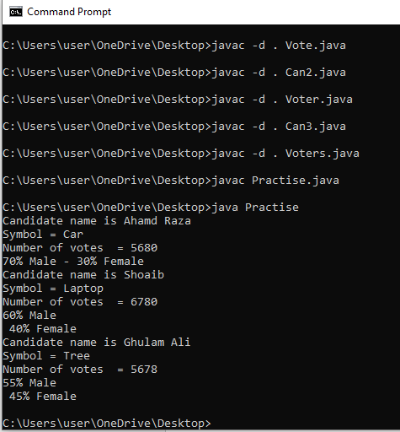

Exercise 2 (Interfaces)

1. What is wrong with the following interface?

public interface SomethingIsWrong {

void aMethod(int aValue){

System.out.println("Hi Mom");

}

}

1. Fix the interface in question 1.
2. Is the following interface valid?

public interface Marker {

}

1.In interface we can not have body of a method so Sout statement is an error in the given statement.

2.Remove that {System.out.println("Hi Mom");} And then the interface will work properly.

3. Yes the interface is valid.

Exercise 3 (Interfaces)

1. Create the Animal interface.
2. Declare abstract method legs.
3. Declare abstract method eat.
4. Create the Spider, Caterpillar and Cat class that implements animal interface.
5. All classes implement the Animal interface.
6. Implement the eat and legs method.

interface Animal

{

abstract void legs();

abstract void eat();

}

class Spider implements Animal

{

public void legs()

{

System.out.println("Spider has 8 legs");

}

public void eat()

{

System.out.println("Spider eats insects");

}

}

class Caterpiller implements Animal

{

public void legs()

{

System.out.println("Spider has 6 legs");

}

public void eat()

{

System.out.println("Catepiller eats grass");

}

}

class Cat implements Animal

{

public void legs()

{

System.out.println("Spider has 4 legs");

}

public void eat()

{

System.out.println("Cats eat mouse");

}

}

class Task3

{

public static void main(String args[])

{

Spider ob = new Spider();

Caterpiller ob1 = new Caterpiller();

Cat ob2 = new Cat();

ob.legs();

ob.eat();

ob1.legs();

ob1.eat();

ob2.legs();

ob2.eat();

}

}

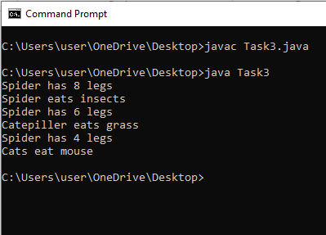

Exercise 4 (Abstract class)

We have to calculate the percentage of marks obtained in three subjects (each out of 100) by student A and in four subjects (each out of 100) by student B. Create an abstract class 'Marks' with an abstract method 'getPercentage'. It is inherited by two other classes 'A' and 'B' each having a method with the same name which returns the percentage of the students. The constructor of student A takes the marks in three subjects as its parameters and the marks in four subjects as its parameters for student B. Create an object for each of the two classes and print the percentage of marks for both the students.

import java.util.\*;

abstract class Marks

{

abstract double getPerct();

}

class A extends Marks

{

int eng , math , calc;

A(int a , int b ,int c)

{

eng = a;

math = b;

calc = c;

}

double getPerct()

{

return ((eng+math+calc)\*100)/300;

}

}

class B extends Marks

{

int eng , math , calc , ict;

B(int a , int b ,int c , int d)

{

eng = a;

math = b;

calc = c;

ict = d;

}

double getPerct()

{

return ((eng+math+calc+ict)\*100)/400;

}

}

class Task4

{

public static void main(String args[])

{

Scanner sc = new Scanner(System.in);

System.out.println("Enter marks of student A!");

System.out.println("=========================");

System.out.print("Subject 1: ");

int w = sc.nextInt();

System.out.print("Subject 2: ");

int x = sc.nextInt();

System.out.print("Subject 3: ");

int y = sc.nextInt();

A ob = new A(w , x, y);

System.out.println("Enter marks of student B!");

System.out.println("=========================");

System.out.print("Subject 1: ");

int l = sc.nextInt();

System.out.print("Subject 2: ");

int m = sc.nextInt();

System.out.print("Subject 3: ");

int n = sc.nextInt();

System.out.print("Subject 4: ");

int o = sc.nextInt();

B ob1 = new B(l, m, n, o);

System.out.println("percetntage of student A = "+ob.getPerct()+"%");

System.out.println("percetntage of student B = "+ob1.getPerct()+"%");

}

}

